Goals and Research questions
Determine the probability that a patient could be more susceptible to suffer heart disease according with the variables more representatives that contributes to classify the detection of the disease.

Hypothesis:
The study want to resolve the question: Which are the principal factors that make more likelihood to a person has a heart disease after know the clinical results of several tests that consider since the physical practice with exercise stress tests until electrocardiograms and blood tests that help to understand the detection of heart disease? The proposal to determine a relative difference is consider the implementation of classification models, in this case, it will be apply a Generalized Linear Model and a Support Vectorial Machine to classify the groups that has or not a heart disease detection with the principal purpose to determine new entries that will be tested in a test dataset how the models will predict new incomes after the training process.

Data source:
The data source proceed from an open data set available on https://www.kaggle.com/ronitf/heart-disease-uci where the database contains 14 attributes with the descriptions about the explanation of certain variables considered to the study of heart disease detection. On the same context, the data does not contain problems of missing values, error or corrupted information, the total of registers are 303 patients and the data was uploaded through csv using the pandas library on python. To understand some variables that are necessary for the study was researched in different medical sources that meaningful of this variables
10. oldpeak = ST depression induced by exercise relative to rest ('ST' relates to positions on the ECG plot) ¹
¹ The ST segment is the flat, isoelectric section of the ECG between the end of the S wave (the J point) and the beginning of the T wave. The ST Segment represents the interval between ventricular depolarization and repolarization. The most important cause of ST segment abnormality (elevation or depression) is myocardial ischaemia or infarction. (See image - ST Segment)
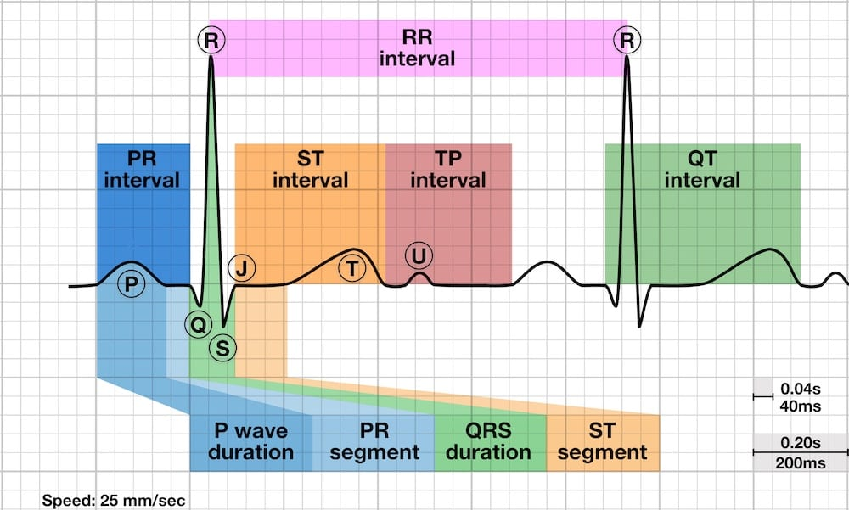
11. slope = the slope of the peak exercise ST segment (Value 1: upsloping, Value 2: flat, Value 3: downsloping) ²
² Morphology of ST Depression ST depression can be either upsloping, downsloping, or horizontal. Horizontal or downsloping ST depression ≥ 0.5 mm at the J-point in ≥ 2 contiguous leads indicates myocardial ischaemia (according to the 2007 Task Force Criteria). Upsloping ST depression in the precordial leads with prominent De Winter T waves is highly specific for occlusion of the LAD. Reciprocal change has a morphology that resembles “upside down” ST elevation and is seen in leads electrically opposite to the site of infarction. Posterior MI manifests as horizontal ST depression in V1-3 and is associated with upright T waves and tall R waves. (See Image - ST Depression)
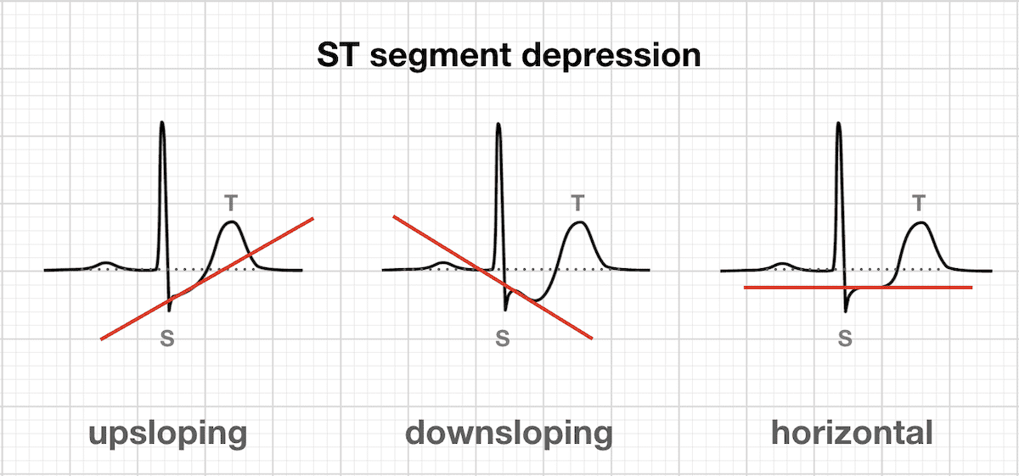

Considering a better understanding of the variables and with a little more of research, is a key factor the relationship between the age and thalach = maximum heart rate achieved, so it is included like calculated variable this relation with the variable called Propension. Source of Information: Kaggle,What causes Heart Disease

The techniques applied to do the descriptive analysis consider the application of summary describe function in python that provides the principal features such as mean, min, max, IQR including the variance seen with the function var(), respect to the graphic part was used histograms and boxplots that guarantee to see the whole distribution of each variable to identify possible outliers, skewness and variance in the variables. Considering there is the presence of some outliers have not represented the necessity to exclude them of the study since are more important the values that have this patients into another variables that contributes to the model.
Analogously, to considerer new variables that could contribute with major representation was needed to research in several sources of information the understanding of what factors are more probably to affect in a heart disease because with this knowledge is possible to construct new variables that enable the possibility to obtain better performances at the moment of apply the classification model.
For the analysis is critical to evaluate the independence of the variables that will be considered in the study and the level of contribution to the model. In this case, it was considered the evaluation of independence using the correlation matrix for numerical variables

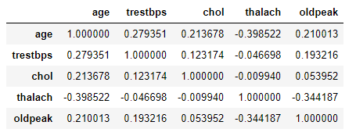
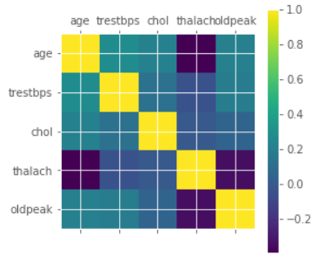
The correlations indicates there are no high correlations coefficients between the variables considered. -39.9% is the highest value between thalach vs. age but it is not considered like a high inverse correlation relation. Hence, according to the dependence of the variables, any variable will be excluded for the study.
Another important indicator that will be used is the KS Index which is defined by

$$F_{n.disease}\left(a\right)=\frac{1}{n}\sum_{i=1}^{n}{I (}s_{i}≤a ∧ D_{k}=1)$$

$$F_{m.no detection}\left(a\right)=\frac{1}{m}\sum_{i=1}^{m}{I (}s_{i}≤a ∧ D_{k}=0) with a∈\left[L,H\right] \begin{matrix}L=\min{value S_{i}} \\ H=\max{value S_{i} }\end{matrix}$$

$$D_{k}=\left\{ \begin{aligned}1 \\ 0\end{aligned} \begin{aligned}Heart Disease Detected \\ No detection\end{aligned}\right.$$

$$KS=\max_{a∈[L,H]}\left|F_{n.disease}\left(a\right)-F_{m.no detection}\left(a\right)\right|$$
For the numerical variables, the KS Index was calculated over the partition by deciles over the variables
(Note: Reference in this part to the Appendix section with the results of the deciles ranges)
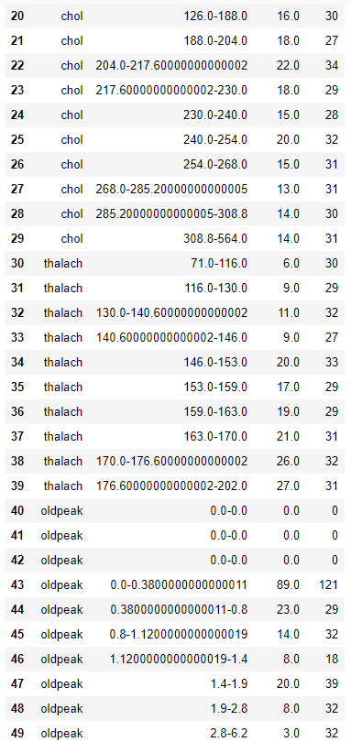
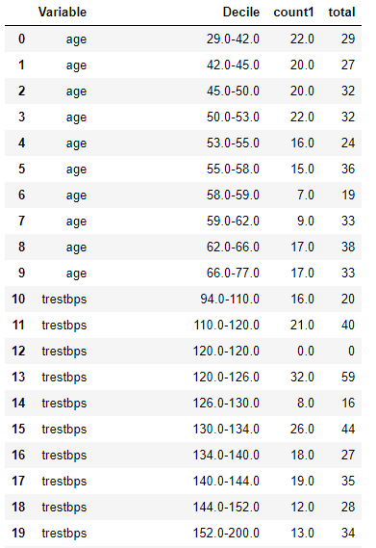

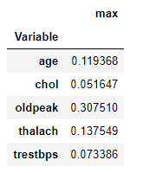
The calculated KS for numerical variables is

According with the KS results, the variable with KS>20% is the variable oldpeak, the other variables could not achieve a minimum of 20%. For this reason, oldpeak will be considered like a pre-select variable for the model.
For categorical variables, the KS>20% are evidentiated in the variables ca=46%,cp=52%,exang=41%,propension=22%,sex=26%,slope=39%

Normalization
The next important step before apply the classification model is standardized the variables to equilibrate in a same measure all the variables without affect the different scales of measurement of each variable. In this case will be considered a log odds transformation according to the following definition
$$LogOdds=\frac{N_{(Disease Detection)}}{N_{(No Detection)}}$$

Fitting model

After the normalization of the variables, it will be apply two classification models that fits to the dataset. One is Generalized Linear Model - GLM with logit function define by
$$logit\left(\frac{π}{1-π}\right)=x^{T}β$$
And it will be consider a Support Vectorial Machine SVM with a sigmoid kernel define by
$$k\left(x_{i},x_{j}\right)=tanh\left(ax_{i}x_{j}-b\right)$$
To this particular case, the SVM can be applied since as the volume of the data is manageable to apply this method.
For the GLM application is used the library GLM from statsmodels module where it will be consider according to the evaluation of performance indicators such as P values, Akaike Information Criterion the decanting of the variables that contribute to the model significantly, i.e, P values << α=0.05 that implies that can be rejected the null hypothesis $H_{0}≔ x_{i}=0 , ∀i=\overline{1,n}$ with decreasing values for the AIC.
Variables | P Values
Intercept | 2.152368e-43
LN Propension | 3.385478e-06
LN ca | 2.231922e-06
LN slope | 1.337189e-03
LN exang | 1.820553e-04
LN cp | 1.385082e-12
LN sex | 4.001657e-01

At the first application, the results show that the variable $\ln_{sex}$ has a p value= 0.4 > α=0.05, for this reason, the variable cannot be reject the null hypothesis and not contribute with the model. Consequently, will be dropped from the variables $\ln_{sex}$. Adjusting the new model, the results are the following
Variables | P Values
Intercept | 1.419439e-51
LN Propension | 4.102678e-06
LN ca | 1.375774e-06
LN slope | 1.507415e-03
LN exang | 1.474819e-04
LN cp | 1.260075e-14

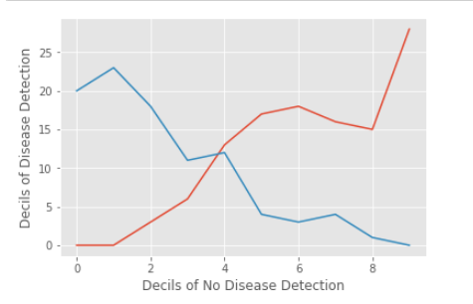
The AIC_2=155.02 < AIC_1=156.29 the AIC reduction represents a good performance of the model, and all the variables have P_values<<α=0.05, hence, all the variables contribute to the model. The next step is considered the definition of the probability of disease from the study of the percentiles of 10% over the train set. According to the graphic, the range of the deciles where it has a definition of separation between heart detection and not detection is considered the intersection point like the minimum level of the range 0.618527432515091

Finally, will be considered the performance of a SVM over the same train and test data to compare with the execution of the GLM model using like kernel a sigmoid adjusting.

Testing model

MLG Results
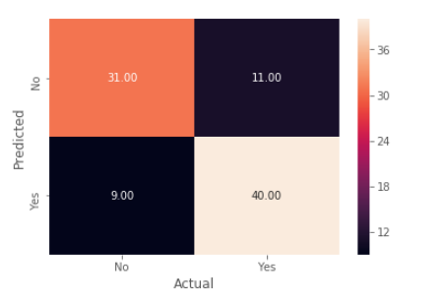
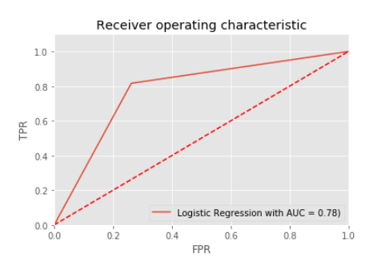

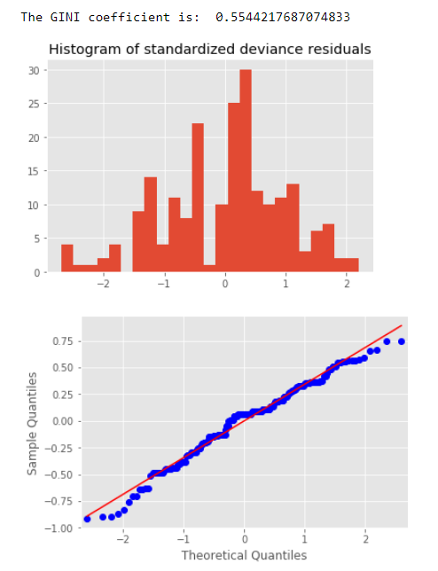

According with the matrix confusion with error type 1 and 2 are of 21.9%, with a precision of 78.4% with no signs of overfitting pattern. Analogously, the AUC ROC= 78% <95% considered with good levels of prediction and without overestimate, also the GINI Index = 55% has a good performance. The p_values are with α<<0.05 for all the variables so the H0:= Xi=0 ∀ i={1,...,n} ,i.e, the variables contribute to the model, thence the null hypothesis can be rejected. Finally, with the residuals analysis, the histogram of the standardized residuals are centralized on average, but it is not Gaussian distributed because could fit a bimodal distribution with the begin and final tails with an interruption over the continues frequency, in the same context the qqplot and qqlines belongs between [-3,3] with and adjustment almost normal distributed.
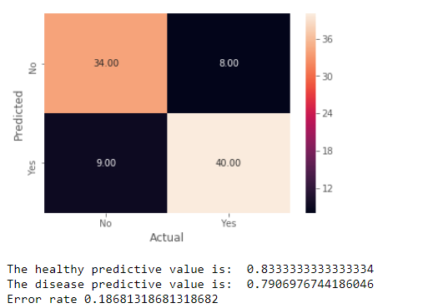
SVM Results

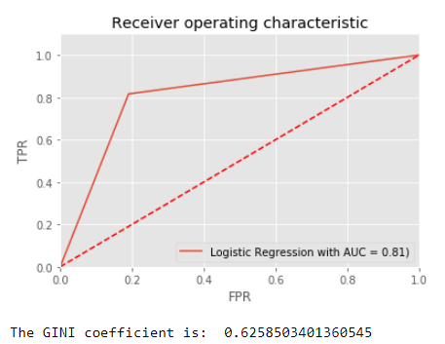

In contrast, the SVM model with sigmoid kernel has a better performance than the GLM model with accuracy_glm=78% > accuracy_svm=83%, analogously, the error rate in the SVM model is 18% while in GLM is 22%, the AUC_svm=81% > AUC_glm=78% and the GINI index is a +7% higher on SVM than GLM.

Conclusions:

Only for this study were available 14 of 76 variables from the original study this exclusions could be important to evaluate new combinations of derivate variables that let see some extra interactions that adjust better performances. In this sample the data was not representative over a total population in certain city or country, the selection of the data resembles the visitants that could have a specific doctor during a period of time and cannot be concluded over a deterministic group of study.

